Policy plan  
Stichting Soil Heroes Foundation

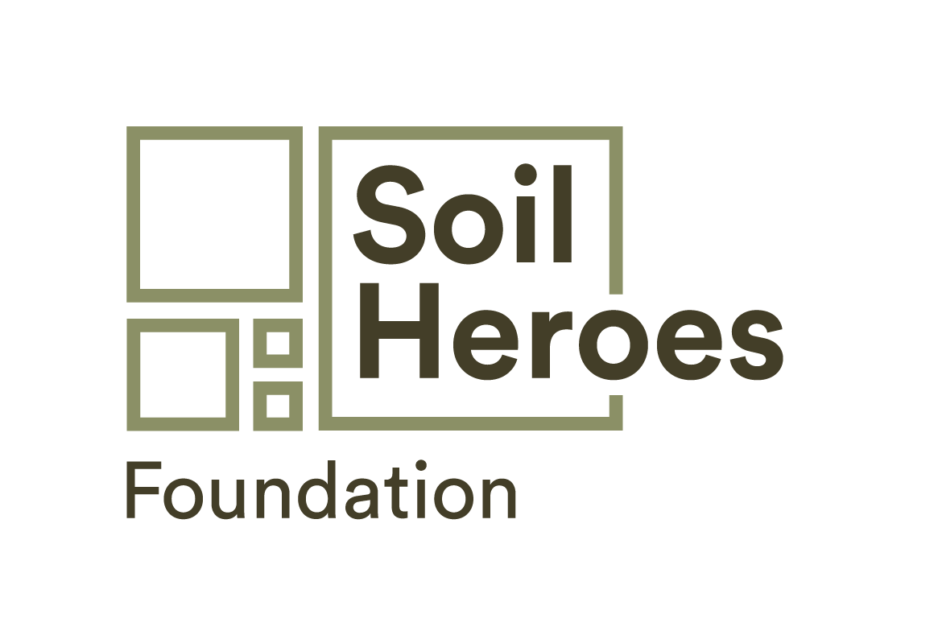

Increasing the quality of life on earth for the long term

by catalysing the transition to regenerative agriculture

* New and fair business models for farmers
* Increased nutritional value in food
* A more stable climate and healthy planet
* Restored soil health, biodiversity, water and air quality

Stichting Soilheroes Foundation

RSIN: 8598.48.206

Registered address: Stougjesdijk 168, 3271 KG Mijnsheerenland, The Netherlands

annabelle@soilheroesfoundation.com

CoC: 74307878

Exhausted lands

Soil is the new gold. It is the greatest asset a farmer owns, yet for decades, worldwide, it has been neglected, overused, depleted. Since the start of the industrial agricultural revolution, an overreliance on synthetic inputs and intensive monoculture farming practices have robbed the ground’s capacity to provide the things we depend on for life itself - clean air and water, thriving biodiversity and nutritious food - to name just a few of the vital ‘ecosystem services’ provided by our soils.

A downward cycle

The narrow focus, for more than half a century, on increasing productivity, has allowed us to overlook the full range of services that soil provides humanity. Intensive agriculture has pushed farmers into dependency on artificial inputs for short term gain - yet the reality is long term failure and financial and contractual commitments which hold them in this negative cycle. Their continued destructive agricultural practices reduce soil quality further, creating a vicious downward spiral.

Universal crises

The problems that poor soils bring are universal and include: contributing to the catastrophic climate change, poor regulation of water (a lack of water holding capacity in droughts, poor drainage during periods of heavy rainfall), chronic public health issues, failing harvests for vital food supplies and declining biodiversity - which is essential for the organic processes above and below ground to repair and keep our ecosystems healthy. The negative impact of degraded soils has been widely acknowledged by governments, many businesses, and communities as evident in the Paris Agreement and the burgeoning interest globally to invest in land restoration. Change is needed. Now.

Solution - Nature knows best

The simple fact is that nature holds the key to our survival. Biological processes repair and enrich soils. A vibrant diversity of plant, insect, bird and animal life creates the rich organic matter needed for these processes. In turn, soil can hold more water, absorb more carbon and do this more efficiently, and provide more nutrition for human consumption. A nature-friendly way of farming is regenerative farming, and the benefits, despite being ignored by the mainstream, have been known for decades.

Regenerative Agriculture

In short, regenerative farming is a way of using the land that works with nature. It is using the chemical and biological power of nature itself to heal soils and make crops flourish. Bees, worms, compost, biomass are all mother nature’s luscious, transformative tools. Regenerative practices harness what nature offers and has been proven not only to increase soil health but also farmers’ yields and profit:

Increase

* Crops resilience
* Yields
* Quality & Nutrition
* Profitability (long term)
* Intrinsic land value
* Natural capital
* Climate resilience

Decrease

* Costs
* Artificial inputs
* Need to irrigate
* Harvest volatility
* Top soil loss
* Soil degradation
* Run off & drought

Stichting Soil Heroes Foundation focuses on increasing the quality of life on earth for the long term. We do this by stimulating the transition to regenerative agriculture. Next to our main focus of improving soil health, we strive to increase the impact of ecosystem services. This enables farmers to gain directly from their transition and so secure long term impact.

Focus areas

Our four main areas of focus are designed to support and persuade farmers to transition to regenerative farming and make it the new standard worldwide;

1. Providing proof of practice. We will make the practice and impact of regenerative farming measurable and visible by trialling techniques and gathering and sharing results.
2. Building networks and creating an enabling environment. We will create a positive environment to support regenerative farming. We will verify results with international experts and make our findings open source. We will provide creditability and encourage uptake through farmers, experts, organisations and networks.
3. Inspiring action. We will demonstrate the potential for soil improvement as a result of regenerative practices. This we do by sharing the effects it has for the soil, income, product quality, climate and the health of our planet in general.

Target audience

First and foremost, we will empower farmers to be part of the regenerative revolution by communicating the importance and positive impact of regenerative practices. With farmers being an all-purpose word, we understand that there is a wide variety of different farmers. Our outreach will be global and our initial focus will be on those who already have a certain vision - for the environment, the climate, the economy for the future. This group is the most likely to embrace this transition and will eventually help to inspire more and more farmers  
  
In addition to farmers, the Soil Heroes Foundation also aims to reach organisations, companies, knowledge institutes, governments and consumers as they all form a vital part in the transition; for co-development, knowledge sharing, validating and/or being the potential buyers of products and ecosystem services.

In short – Stichting Soil Heroes Foundation is a non-profit organisation, focused solely on serving the common interest of the transition to regenerative farming.

Our mission

To enable to the long-term viability of people in harmony with the planet.

Our goal

To stimulate and establish a regenerative society where the restoration of soil health, soil biodiversity and the production of food with a higher nutrient density is central.

Overall objective

To catalyse the transition to regenerative farming globally.

Our approach

Support and stimulate regenerative initiatives globally and initiate and innovate ourselves.

Eventually leading to

* Restored soil health, biodiversity, water and air quality
* New and fair business models for farmers
* Increased nutritional value in food
* A more stable climate and healthy planet

Stichting Soil Heroes Foundation holds a Golden Share of the Soil Heroes Operations to protect the purpose of the business, restoring soils for people and planet.

Board Composition

The Soil Heroes Foundation is made up of a Management Board and an Executive Team.

The composition of the Management Board is the following:

* Ms. Annelies van der Vorm (Chairwoman) - Impact Investor
* Mr. Frederic Hoffmann (Treasurer) - Food & agriculture deal sourcing for GO!
* Ms. Alexandra Korijn (Secretary of the Board) Co-founder at New AJE Capital, Board member at Toniic

The Management Board is responsible for overseeing the broad mission of the Foundation, as well as the overall management of the Foundation.

A majority of votes applies to decisions made by the Management Board, with each director having the right to cast one vote. The Management Board is not authorised to obtain, alienate and encumber registered property, in accordance with the statutes, unless the Supervisory Board has given its approval for this in writing. The Management Board is also not authorised to enter into agreements whereby the Foundation commits itself as guarantor or joint debtor.

In accordance with the statutes, no remuneration is awarded to the Management Board. All board members can receive an expense allowance.

Financial details

The assets of the Foundation will be formed by:

1. Subsidies and other contributions;
2. Gifts, inheritances and legacies;
3. All other acquisitions and benefits.
4. SH -Company has committed to 1% of turnover donated to SH Foundation

The Foundation can only accept successions under the privilege of inventory.